# I3 Team Report - Sprint 4

## Reflection

| Project Status |
| --- |

For the fourth and final sprint of the semester, our total story points were very low as some of the tickets had really low estimates compared to actual time spent. Both Isaac and Filipe had to spend over 15 hours each on the RSync ticket despite it being noted as an 8-hour ticket. Similarly, Sanjay had added a lot of additional features to his tickets that took him much longer than 8 hours each. We have completed the Create Assessment and Edit Assessment pages on the UC client. A few functionalities like Questions and Notifications have also been added to these clients. On the backend, after having a group in-person consultation with lecturer Dr. Sonny Pham for advice on the security setup, we have fully implemented the RSync setup as needed and connected it to the frontend. As for the submission documents, we have completed the written sections of the Award Submission Summary and will be discussing with the client for the Benefits Realization section.

Plans for Final Handover

* Finishing the remaining cards from this sprint.
* Thorough application testing through virtual machines on the lab machines.
* Meeting with the client and letting the client test the final application.
* Consultation session with client to complete Benefits Realization section from Award Submission Summary.
* Preparing Presentation slides + script for Final Presentation.

## Burndown Charts

Below are 2 burndown charts. The first one is based on time completed/remaining (based on estimations from planning poker) and the second one is based on the number of tasks completed.

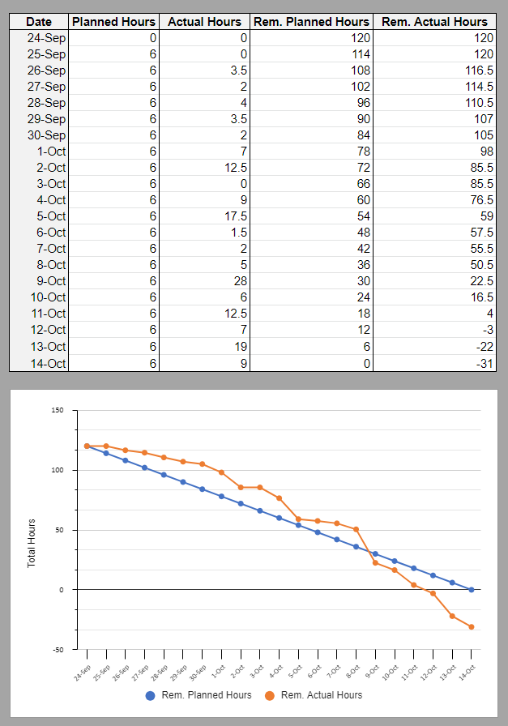

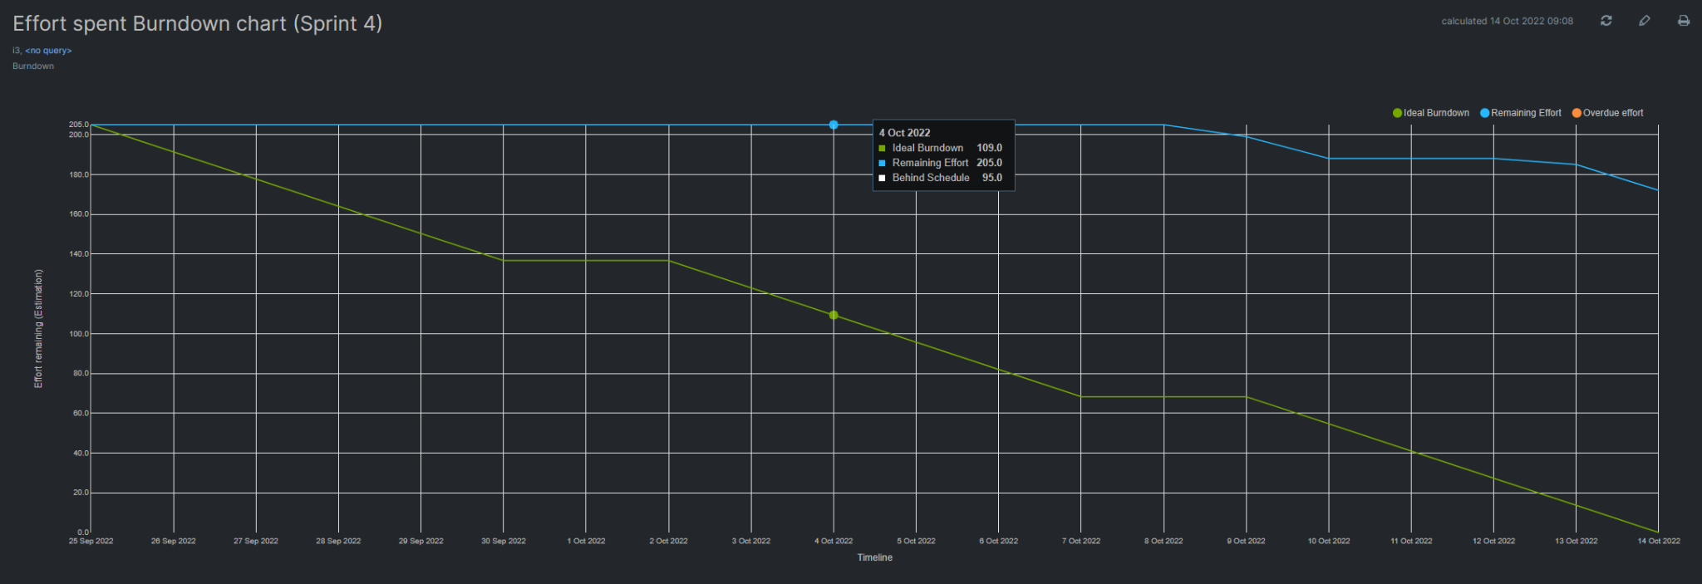

## 

## 

## 

## 

## 

## 

## 

## 

## 

## 

## 

## Toggl Report

## Below is a report generated from Toggl for the last 3 weeks.

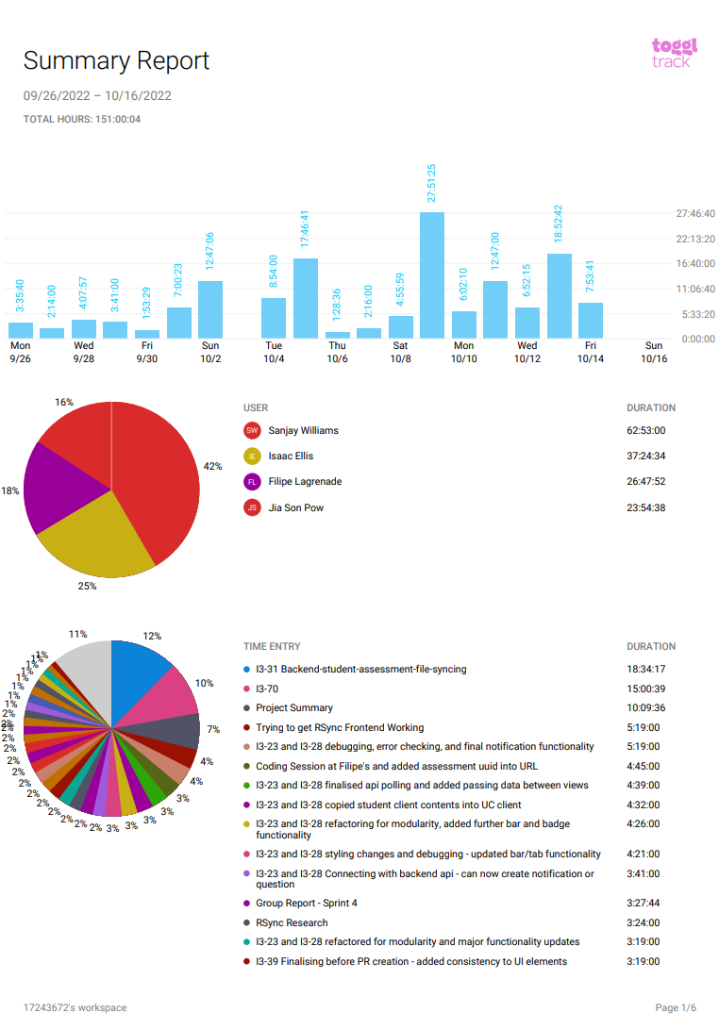

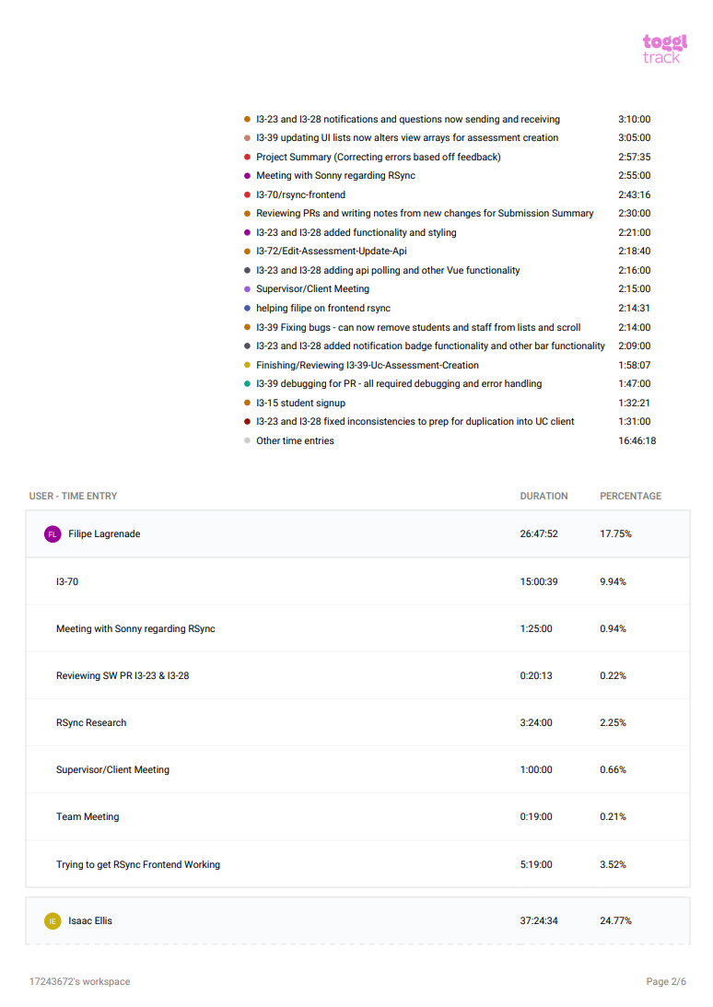

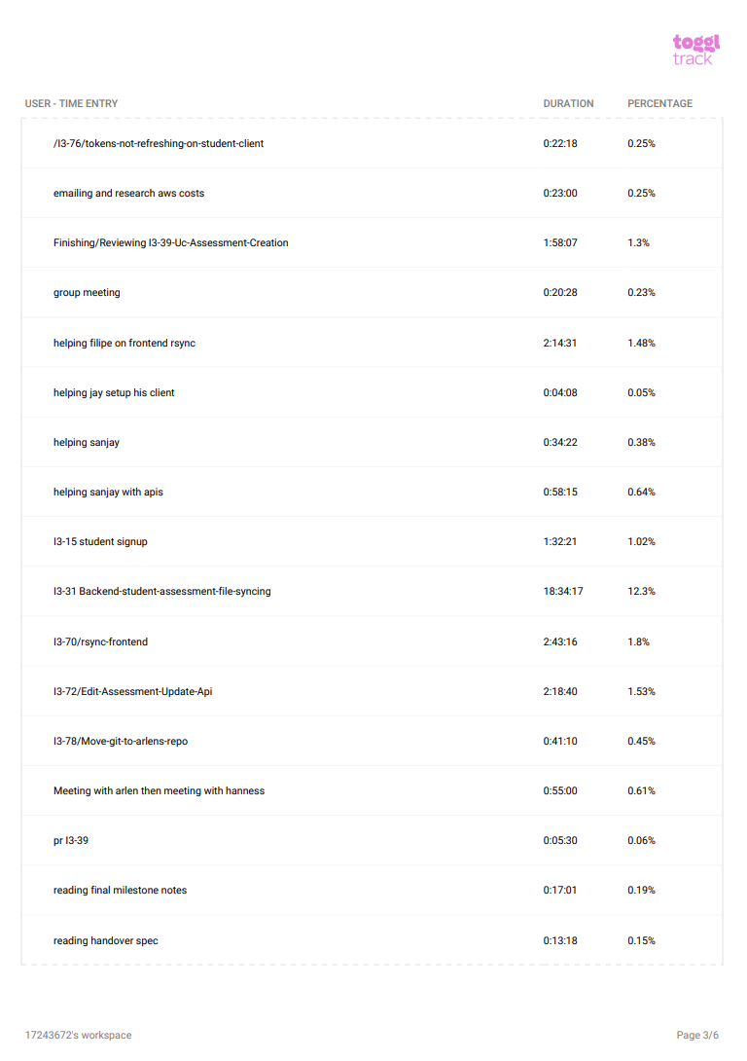

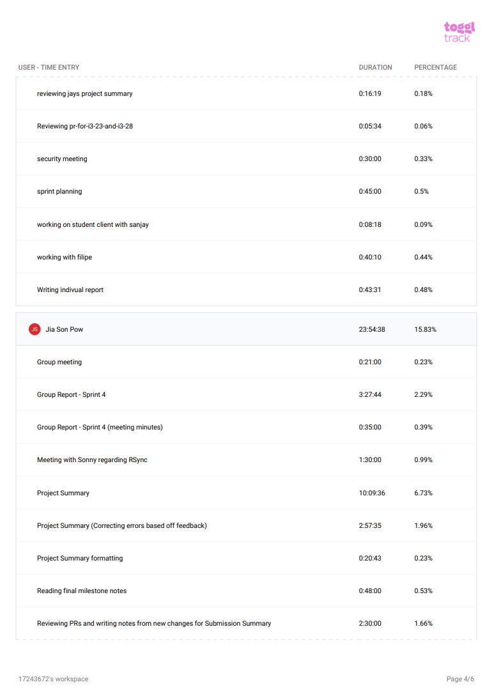

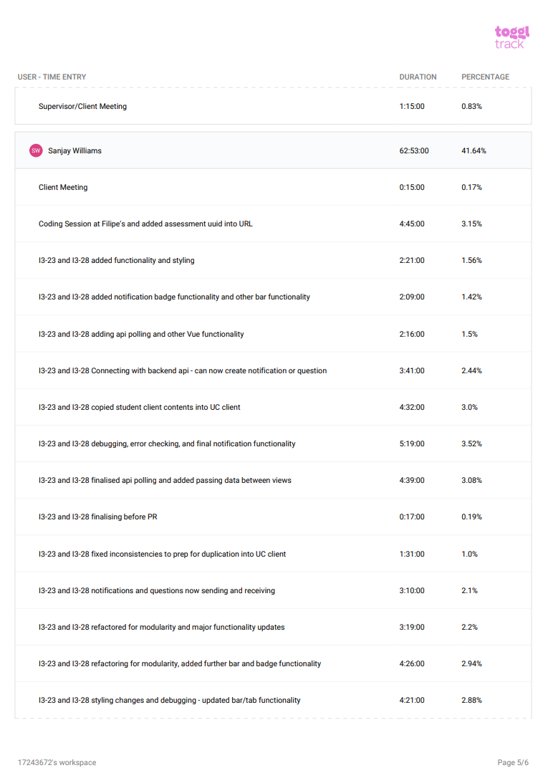

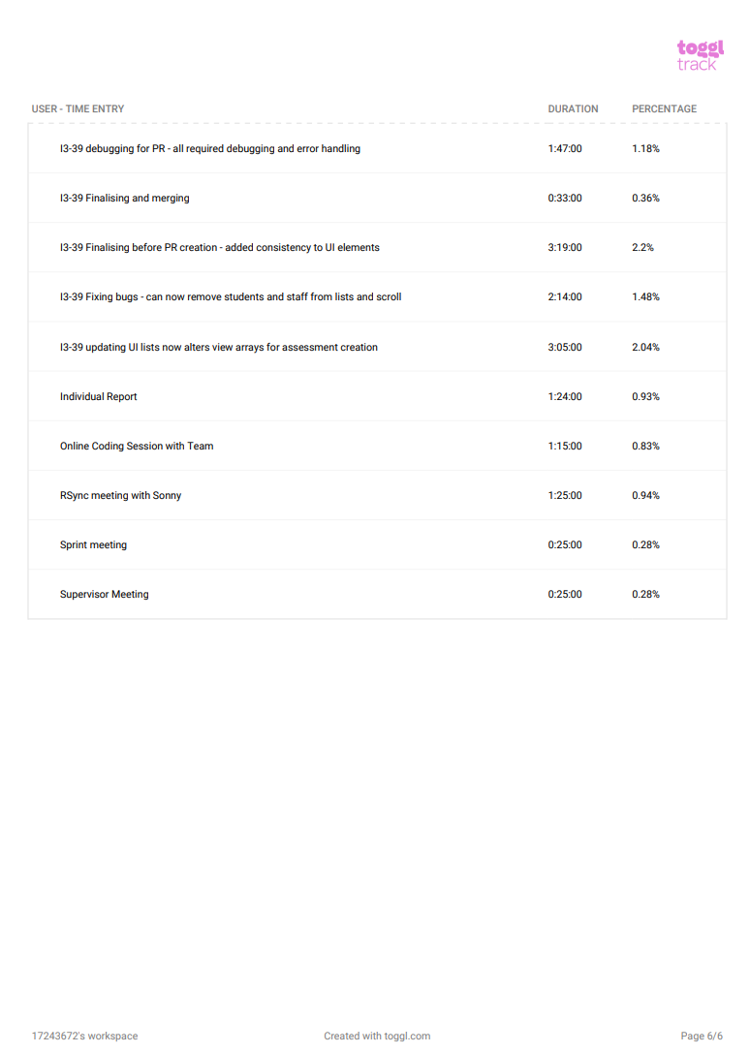

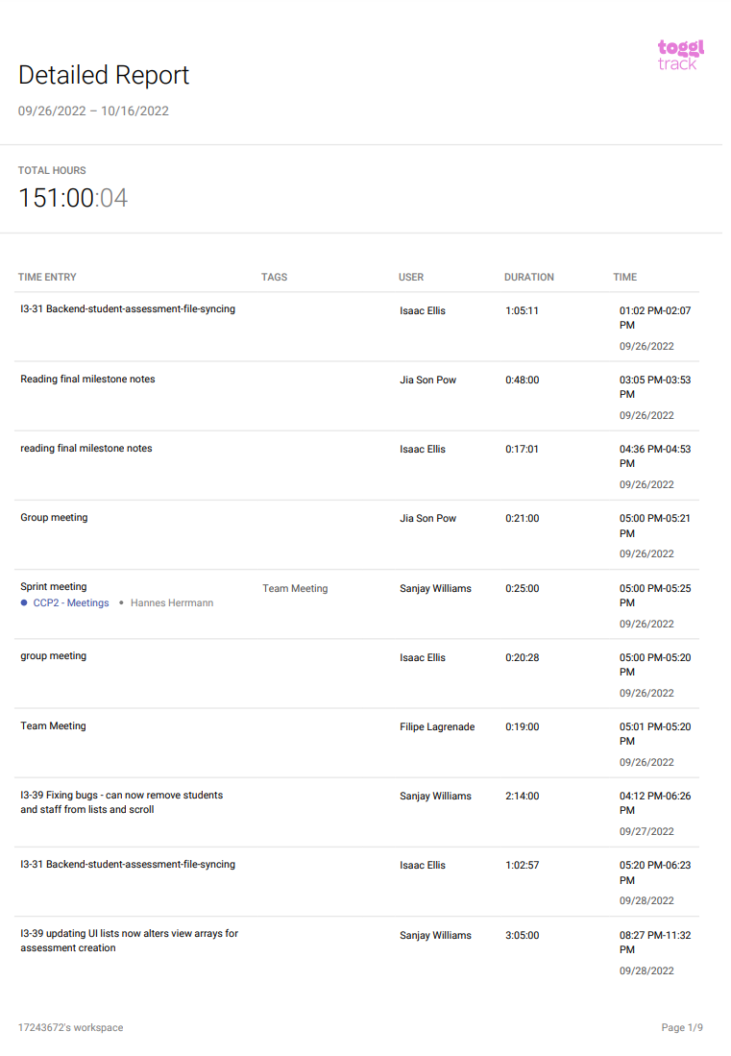

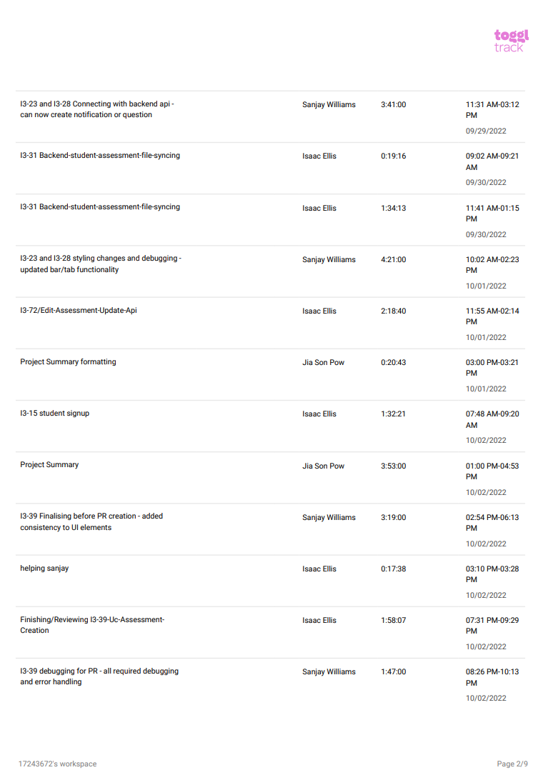

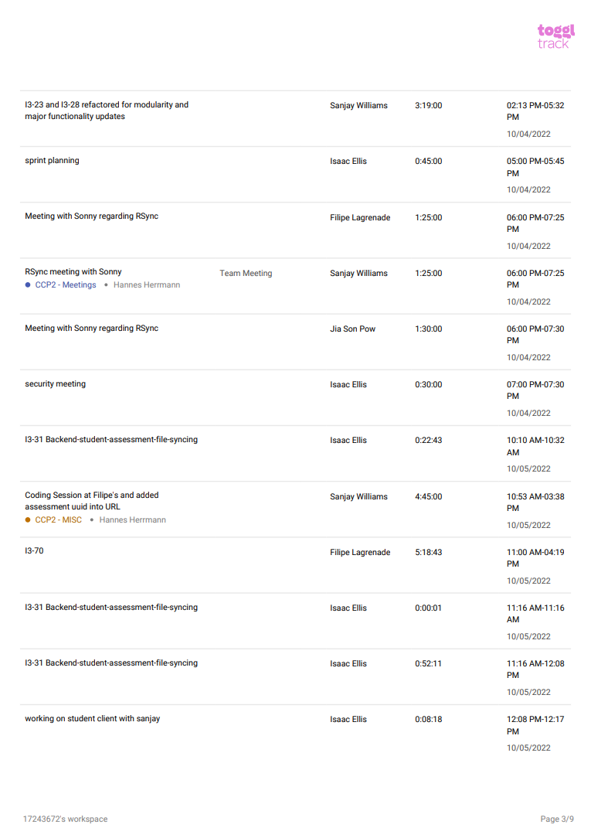

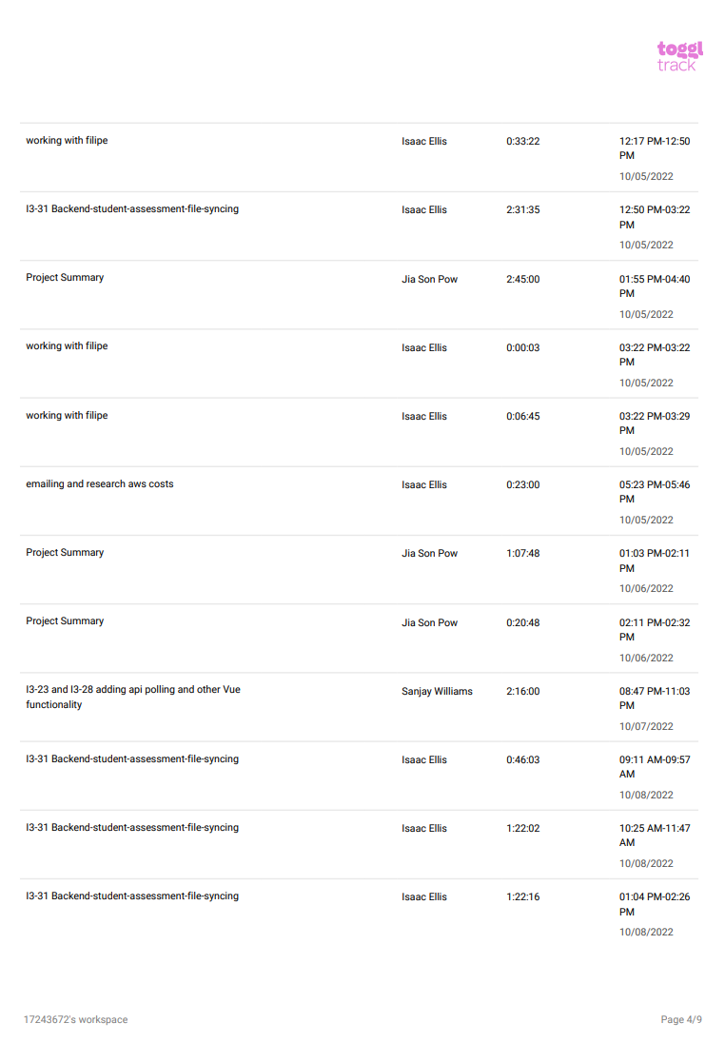

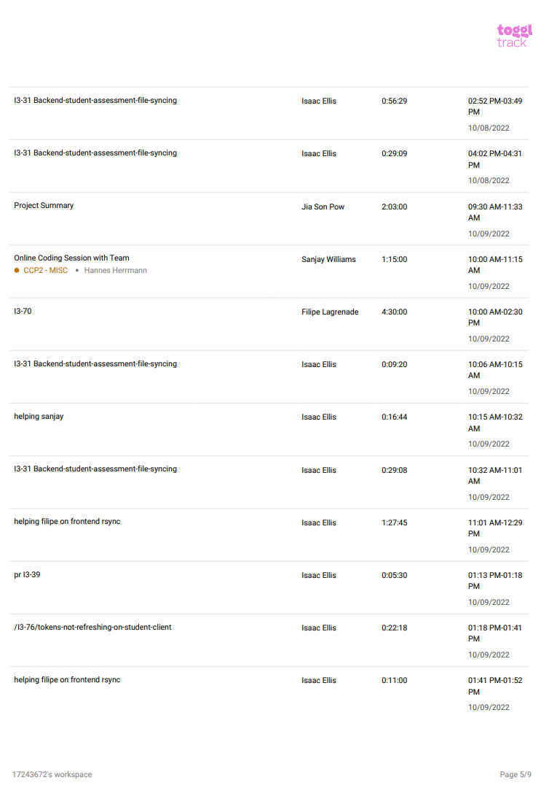

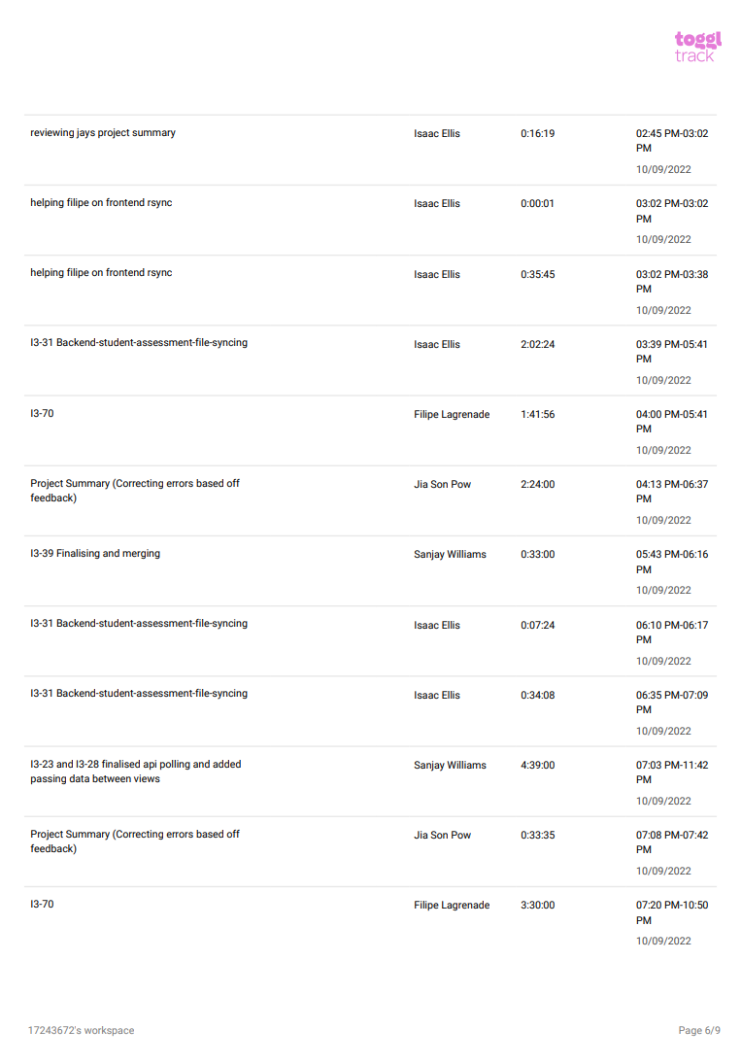

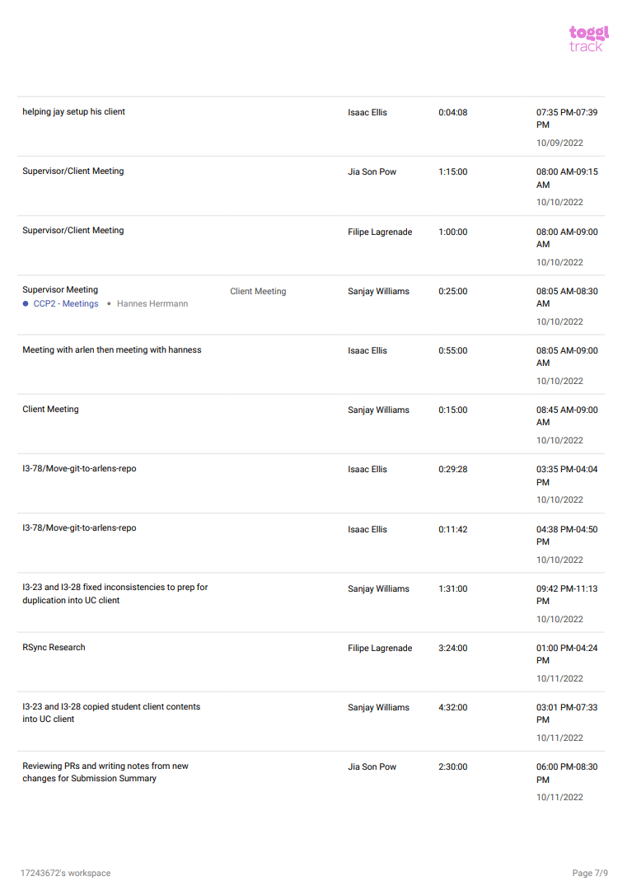

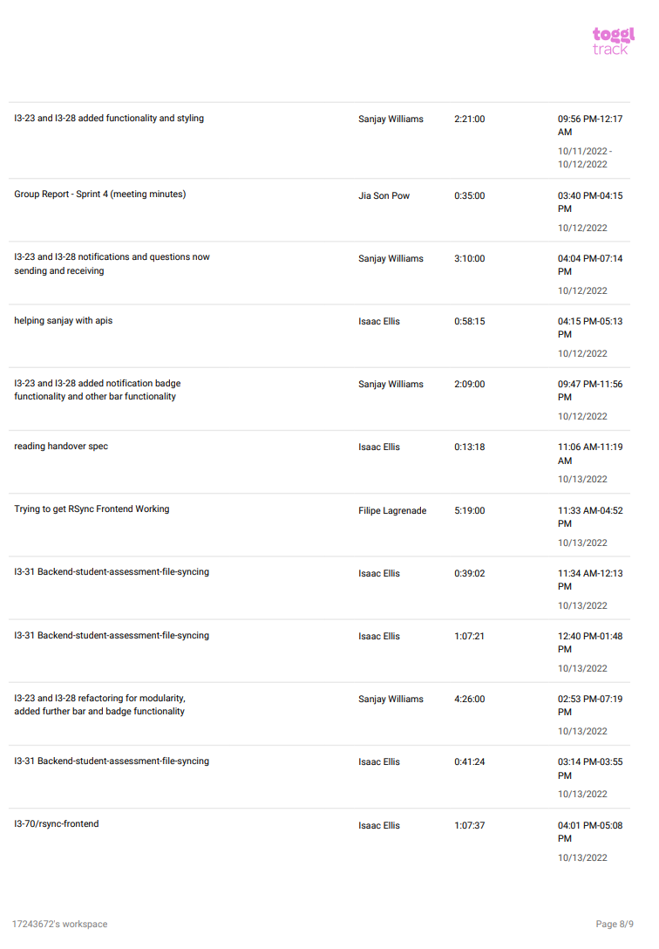

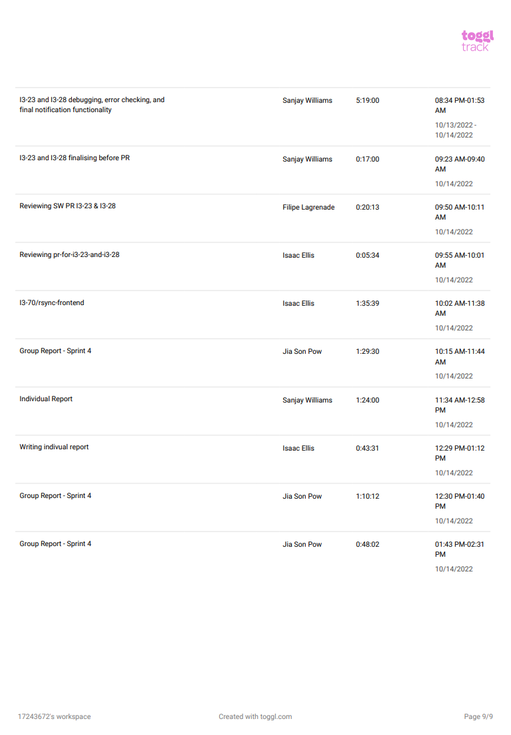

## Tickets completed

| Open | In Progress | Completed |
| --- | --- | --- |
| I3-44 UC/Admin to View/Edit Upcoming Assessment | I3-70 Rsync Frontend | I3-31 Backend Student Assessment file sync |
| I3-71 UC/Student Password Reset Client Frontend | I3-15 Student Signup | I3-72 Edit Assessment Update API |
| I3-80 Delete SSH users when an assessment ends | I3-84 Sprint 4 Group Report & Agile Work | I3-76 Tokens not refreshing on Student Client |
| I3-82 Secure APIs that can only be called during active assessment |  | I3-74 Award Submission Parts B/C |
| I3-75 SRS Adjustments |  | I3-39 UC Assessment Creation Frontend |
| I3-79 Backend SSH (security jail) |  | I3-78 Move Git to Arlen’s Repo |
| I3-81 Replace all use of alert() with toastr notifications |  | I3-83 Fix file EOL in Git |
|  |  | I3-23 Questions frontend for UC/Student clients |
|  |  | I3-28 Notifications frontend for UC client |
|  |  |  |

## Attribution of Work

| Ticket | Team Member |
| --- | --- |
| I3-31 Backend Student Assessment file sync | Isaac Ellis |
| I3-72 Edit Assessment Update API | Isaac Ellis |
| I3-76 Tokens not refreshing on Student Client | Isaac Ellis |
| I3-74 Award Submission Parts B/C | Jia Son Pow |
| I3-39 UC Assessment Creation Frontend | Sanjay Williams |
| I3-78 Move Git to Arlen’s Repo | Isaac Ellis |
| I3-83 Fix file EOL in Git | Isaac Ellis |
| I3-23 Questions frontend for UC/Student clients | Sanjay Williams |
| I3-28 Notifications frontend for UC client | Sanjay Williams |
| I3-70 Rsync Frontend | Filipe Lagrenade, Isaac Ellis |
| I3-15 Student Signup | Isaac Ellis |
| I3-84 Sprint 4 Group Report & Agile Work | Jia Son Pow |

## Repository

Below is a link to the bitbucket repository.

<https://bitbucket.org/curtincomputingprojects/2022-i3-super-lab-assessment.git>

Meeting Minutes

